(Approx. 1646 words)

President's Corner
SOC - Save Our Connectors
By Greg Skalka, President, Under the Computer Hood User Group, CA
Drive Light newsletter
www.uchug.org
president (at) uchug.org

In the early part of the 20th century, the internationally recognized way to signal that your ship was in distress was to send a radio telegraph message of three dots, three dashes, and three dots in Morse Code. This translated to “SOS”, which, though selected as a distinctive pattern, became associated with the phrases “Save Our Souls” and “Save Our Ship.” Though rarely used in Morse Code these days, SOS in the printed and spoken forms is still associated with distress situations.

When our tech devices are in distress, they seldom send us such a clear and unmistakable signal of their condition. We usually have to interpret indications of faulty operation to determine when and why our devices are having problems. One problem our devices can have is failing connectors. There are very few truly “wireless” devices in our technology collections; most involve connections through wires or cables at some point in their operation. Interconnecting, charging, and reading/writing data to devices almost always involves some wired connections. These wired connections are typically made through physical electrical connectors on the devices and cables, and unfortunately, these connectors, being mechanical, can and do wear out and fail, especially if frequently connected and disconnected.

We may think of our smartphones as wireless devices, and in most modes of operation, they are. They still come with an electrical connector, however, as that is the most convenient and sometimes only way to charge their internal battery and connect them to other devices for data transfer. The connectors used are usually USB, typically the large Type-A on computers and the smaller Mini, Micro, and Type C on portable devices, while Apple products use the small Lightning connector. These connectors have a rated life that often ranges from a thousand insertions or removals to ten thousand, with 5,000 typical for a good connector. Five thousand connections or disconnections for a connector’s lifetime may seem like a lot, but if you charge a smartphone every day, that uses up two per day or 730 in a year. Connect to the phone three times a week to offload photos and you have over 1000 connections per year, meaning your phone’s connector might work reliably for only five years.

If you bought a lower-end product, used poor-quality cables, or used less care in connecting them or protecting them while connected (allowing large side forces on the cable connector, for example), the lifetimes of the connectors will wind up being even shorter. Lower-cost devices and cables may use low-cost, less reliable connectors. Some connector types may be less costly to manufacturers but also less reliable (such as the now less frequently used USB Mini).
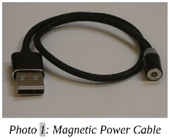In the test engineering world, especially for military products, connector savers are often used to prevent the useful life of product connectors from being reduced by interconnections made in product testing and debug. Connector savers are small adapters with the same type on each end, but with opposite genders. When plugged into a product connector, the connector saver presents to the world the same type and gender as the product connector. The connector saver is plugged into and removed from the product only once in the test cycle, with any necessary additional connections made during testing to the expendable connector saver.

To make your consumer electronic products last longer, you should extend the connector saver concept to your heavily used devices. I have had several perfectly good tech items become unreliable or unusable due to connector problems. Fortunately, there are ways to improve the reliability of failing connectors, as well as steps that can be taken to prevent connector wear failures and extend the life of product connectors.
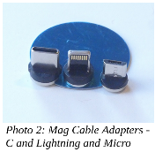
For most of us, our smartphones are in constant use, sometimes requiring multiple charges per day. The risk of wearing out the power/data connectors (on device and cable) is significant if you plan to keep the phone for some time. The cable can usually be replaced when its connectors become unreliable, but when the phone’s connector wears out, it usually cannot be changed. Fortunately, there are now some new products that follow the connector saver concept for USB Micro and C connectors, as well as Apple Lightning.

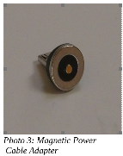Search “magnetic charging cable” on Amazon and you will find some products that hold contact connections together using small but powerful rare-earth magnets. A small magnetic connector adapter is plugged into the phone connector; the cable connects to this adapter through a strong magnet in the cable end, holding them together. This saves the phone’s connector as the adapter remains with the phone and the connection breaks between the two magnetic pieces.

There are cables for charging only (a two-wire connection) as well as cables for data transfer (four-wire). Most come with adapters for USB C and Micro, as well as Lightning.

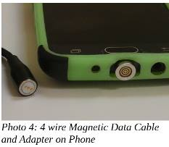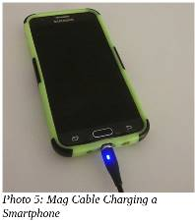I have been using a magnetic data cable with my Samsung smartphone for a month and it works well for charging and transferring data (I have used the Amazon TOPK data cable set and the power cable I have been using a magnetic data cable with my Samsung smartphone for a month and it works well for charging and transferring data (I have used the Amazon TOPK data cable set and the power cable set by Terasako

Because these tiny adapters contain powerful neodymium magnets, care must be taken to keep them away from anything that is magnetically sensitive. The adapters are small and pose the same risks to children as small neodymium magnets.

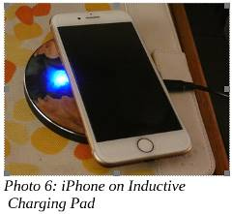Another connector saving option for smartphones, smartwatches, and tablets is the inductive charger. Many devices, including some from Apple and Samsung, follow the Qi wireless charging standard. A wire coil and additional circuitry built into these phones and devices allow a complimentary charging pad to transfer power to the device through inductive coupling. Small wireless charging receiver pads can also be added to the outside of older smartphones (plugging into the normal charging connector) to make them compatible with the Qi charging pads. These wireless charging schemes eliminate connector wear, but inductive charging is less efficient (may take longer) than direct charging.

Though the magnetic charging cables work well, I’ve yet to find one that includes USB Mini in its adapter line-up. The USB Mini connector has a reputation for poor reliability, yet it has been used on many non-phone tech products. I have had three products so far with failed USB Mini connections.

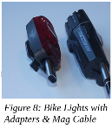I once had a set of three identical USB2 external, hardware-encrypted hard drives (2.5” drive form factor) that I used to store and back up my most important personal and financial data. The drives had USB Mini connectors on their cases and connected to PCs through USB A to Mini cables that came with the drives. After years of use (where I disconnected the cables from the drives when not in use), the cable connection to the drives became unreliable. Trading the cables around helped, as did twisting the cables to put more pressure on the connector, but eventually, I was forced to buy new USB3 drives and discard the old ones. My new drives have a different USB3 connector, but I now leave the cables connected to those drives.

I have a pair of rechargeable bike lights (front and rear) that I normally recharge at least once a week; they have USB Mini connectors to their charging cables. Recently I have been having problems charging them; I’ve had to twist the cable around to make good contact with the connector in the lights. A USB Mini magnetic charging cable would help, but they are not available.

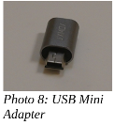I was able to buy a small USB Mini to USB Micro or C adapters. I cannot keep these adapters on the lights as connector savers, as they are too big in this application, but the adapters do help make a better connection to the lights. I am presently using the adapters in conjunction with the magnetic charging cable; this has improved the reliability of the connection. Since I am still making frequent connections to the light’s connectors, I will no doubt eventually need to buy new bike lights.

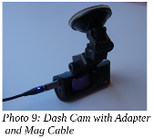I have an auto dashcam (photo 9) that I normally power from a battery through its USB Mini connector. For several years I frequently moved it between cars, disconnecting that Mini connection and eventually wearing it out. Fortunately in this application, I can use the same USB Mini adapter but leave it on at all times, disconnecting it at the magnetic charging/data cable. This seems to be more reliable, and I will now not have to wear the dashcam connector out any further.

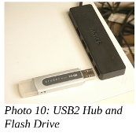The USB Type-A receptacle connectors used on computers and laptops are very robust, but even they wear out eventually. I still run an XP computer as it supports interfaces and programs I cannot run elsewhere. I no longer have it connected to my home network, so I transfer files to and from it through USB Flash drives. After 15 years of use, the two front-panel USB ports on the computer have become unreliable; I often must wiggle the Flash drives to allow them to be recognized. To provide continued access to the computer, I connected a cheap four-port USB hub into one of the computer’s rear-panel USB ports. This provides handy access and acts as a connector saver for the rear ports.

Though your device connectors cannot send a distress signal (other than by failing), you can help extend their lives by using the connector saver concept on heavily-used connectors where possible. Magnetic charging cables, wireless inductive chargers, adapters, and USB hubs can all play a part in reducing connector wear and keeping your devices running longer. Avoid connector disasters - Save Our Connectors!

